This project analyses insurance customer patterns to uncover the key factors influencing policy uptake and annual premium levels. Using a clean Power BI dashboard, I transformed raw insurance records into interactive insights that help insurers understand customer behaviour, risk distribution, and revenue patterns.
Objectives
- Identify demographic and socioeconomic characteristics of insured customers.
- Analyse average policy premiums across age groups, gender, and work status.
- Understand customer loyalty through average months as policyholders.
- Explore relationships between customer profiles and insurance pricing.

Key Insights
- A total of 499 customers were analysed with an average premium of KSH 1.25K.
- Males (67%) were insured more than females (33%).
- Employed customers formed the largest segment (69%), showing higher insurance uptake but the unemployed had the highest average premium policy.
- Customer tenure varied across demographics, with male customers maintaining longer policy periods.
- A clear positive trend was observed between age and likelihood of taking insurance.
Skills Demonstrated
- Data cleaning and transformation in Power Query
- Building dynamic visuals and KPIs
- Designing interactive dashboards
- Creating meaningful storytelling for business decision-making
- Applying analytical techniques to understand customer segmentation
Tools Used
- Power BI (DAX, Visualizations, Data Modelling)
- Excel for initial dataset preparation

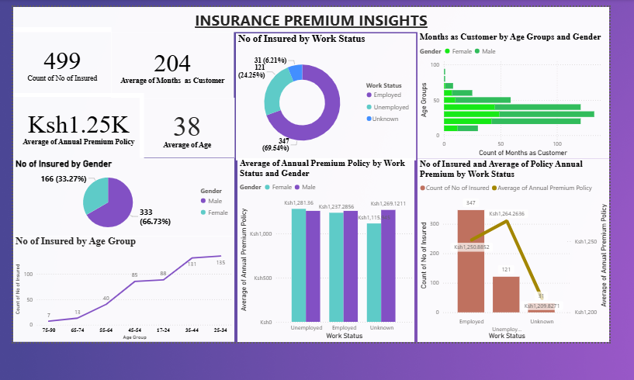
Data Source: Kaggle datasets

